Forest School supports
‘Holistic Development.’

Learning touches the needs of the whole person: mind (head), body (hands) and spirit (heart).
(Williams-Siegfredsen, 2012).
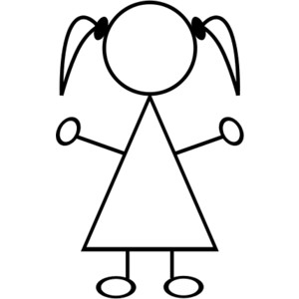
Intellectual development and cognitive skills are expanded through self-directed learning, problem solving and critical thinking.

Head

Hands
Heart

Emotional intelligence is increased through the practise and modelling of healthy social relationships. Creative and spiritual potential is realised through regular engagement with the outdoors.

Physical development that builds
self-esteem and confidence through sensory experiences which promote resilience through supported risk taking and meeting challenges.

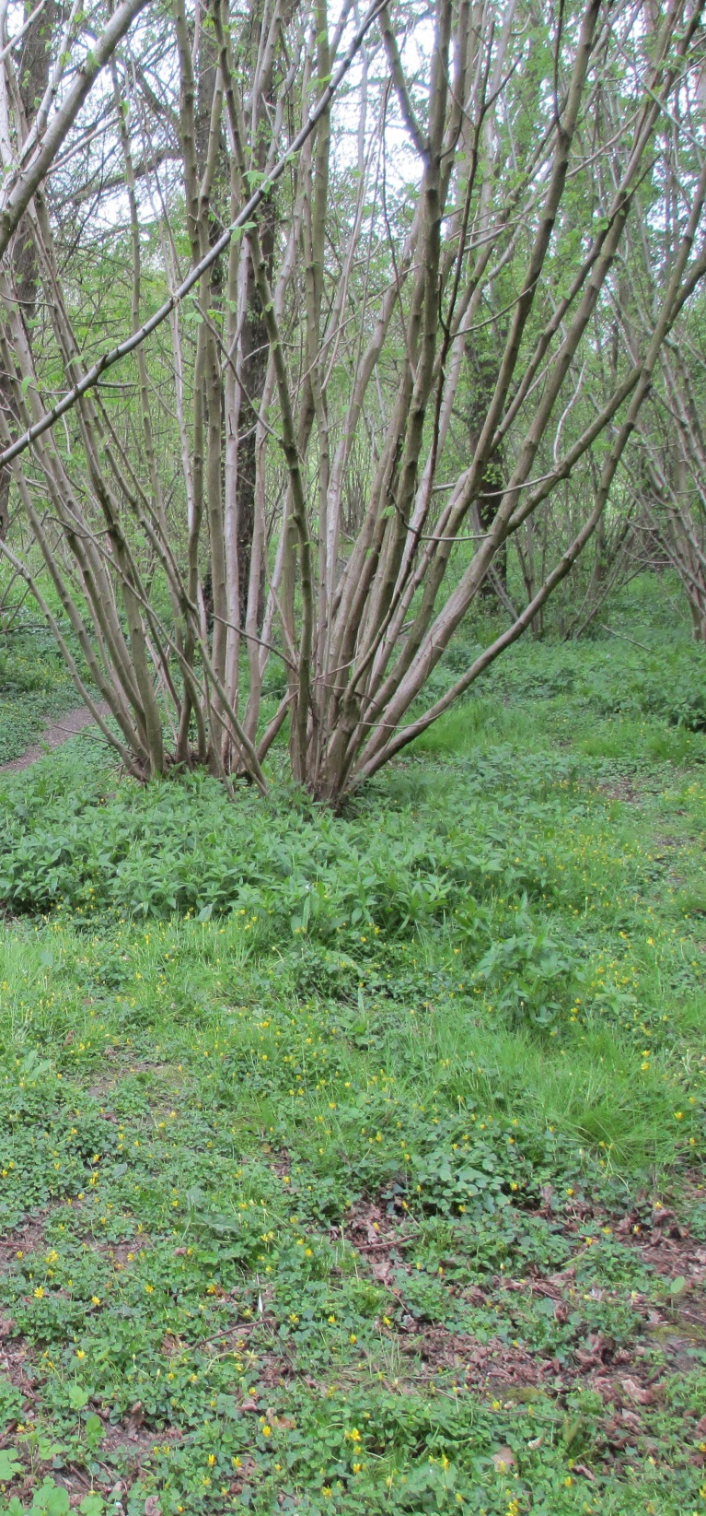
Our Vision Statement
St. Michael’s Forest School is a place where we are inspired by the beautiful, natural surroundings of the Village’s woodland copse. It’s where children are free to learn, play and face challenges creatively, together or independently, at their own pace. It is a safe setting in which we build up our confidence and self-esteem through hands on experiences. Where we take the time to foster great respect and understanding for our natural world and learn how to care for the environment.

Forest School ethos and principles can be
found at:
St. Michael’s
Forest School
at
Steventon Copse
http://www.forestschoolassociation.org

St. Michael’s Forest School Leader is
Sandra Jaeger, Maple Class Teacher, and
takes place at Steventon Village Copse.

For more information or if you would like to be involved in St Michael’s Forest School, please contact St. Michael’s CE Primary School Office at 01235 831298 or email

office3241@st-michaels-pri.oxon.sch.uk

Why Forest School?

Forest School is a specialised learning approach that offers all learners regular opportunities to gain confidence and self-esteem through hands-on experiences
in an outdoor setting.

Forest School incorporates
the marvels and challenges
of the natural world through
the seasons to fill every
Forest School session with
discovery and difference.

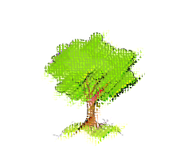

What is Forest School?
- Pupil led learning linked to the National Curriculum

- The freedom to explore using multiple senses

- Small achievable tasks and challenges

- The safe use of our local copse all year round when possible

- A high ratio of adults to children

- Focuses on developing self-esteem and emotional intelligence

- Learning how to respect and care for the local environment
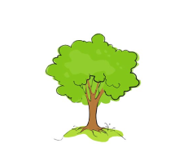

While we have a supply of
waterproof jackets and trousers,
it is important that your child is equipped with the following:

- Wellington boots
- Long trousers (boys and girls)
– all seasons, even summer

- Layers of clothing appropriate to
the temperature and the season

- Hat (for sun or warmth depending on the season)
- Gloves in winter (preferably waterproof)

We have a small supply of school uniforms and extra socks in case they are needed but please send along any extra clothes (such as pants) that you think may be needed. 