**Supporting Your Child’s Learning about our Topic at Home**

There are many ways you can help your child develop his or her own understanding of our topic questions listed above:

• If you have any pets at home, there are many things you can discuss: What does your pet need to live? Are some

of the things similar to what humans need? How is your pet similar to a human? How is your pet different to a

human?

• Post a photo of your child interacting with family pets on Tapestry. Take a video of them talking about how they

help care for their pet by feeding it, taking it for a walk, bathing, cleaning out cage, etc.

• If you don’t have a pet, make a bird feeder (instructions on Tapestry) and put out a bowl of water for thirsty birds.

Talk about ways in which they cope with the winter. Look out for other wild animals like squirrels and deer. Watch

the many red kites that now live amongst us. What are they looking for as they soar through the sky?

• Take a walk outside and make a list of all the living things you see. Take a walk to feed the ducks.

***So please post their learning on Tapestry. We would love to see videos, photos, drawings, or stories about your child’s understanding of how living things survive and if this leads their learning onto other concepts.***

**Reading**

There are free online sources for books that you can read with your child. For example:

<https://www.booktrust.org.uk/books-and-reading/bookfinder/>

<https://home.oxfordowl.co.uk/reading/free-ebooks/>

More specific information will be sent to you soon!

**Contacting Us This Term**

Ms. Jaeger and Mrs Jenkinson share the teaching in Willow Class. Ms. Jaeger teaches Willow Class on Mondays, Tuesdays and Wednesdays; while Mrs. Jenkinson teaches on Thursdays and Fridays. If you have a concern or question, the best way to contact us is by email. Here are our email addresses: [sjaeger@stmichaelspri.co.uk](mailto:sjaeger@stmichaelspri.co.uk) [sjenkinson@stmichaelspri.co.uk](mailto:sjenkinson@stmichaelspri.co.uk)

*While the school is closed for regular teaching, we will check emails throughout the day, but if you need to contact us urgently or quickly, call the school office as there will always be someone in school and they can usually get messages to us quickly.*

**Tapestry**

We will be using Tapestry to deliver our teaching this term while we are not at school, so if you have any trouble accessing it please let us know so we can help. We love to see what your child has been up to as well, so please post photos or videos of your child having fun learning with you at home or outside.

**Happy New Year!**

**It’s already proving to be a challenging one as we move into a strict lockdown and schools have closed for regular teaching.**

**However, we hope that by staying safe at home, it will enable us all to get back to normal life in the near future and we are looking forward to all the positive opportunities that lie ahead for us all in 2021.**

**Our Topic**

Living and Growing - Animals

**Our big question this term is:**

**How do animals survive?**

Last term, we explored how we use our super senses and our brilliant brains to gather information about our world, so now we are going to further this enquiry into the world of animals. How do animals learn about the world? How do they use their special skills to survive? We will be learning what animals need to survive in the wild and what we can do to help them. For more information please see our Term 3 Curriculum Outline. 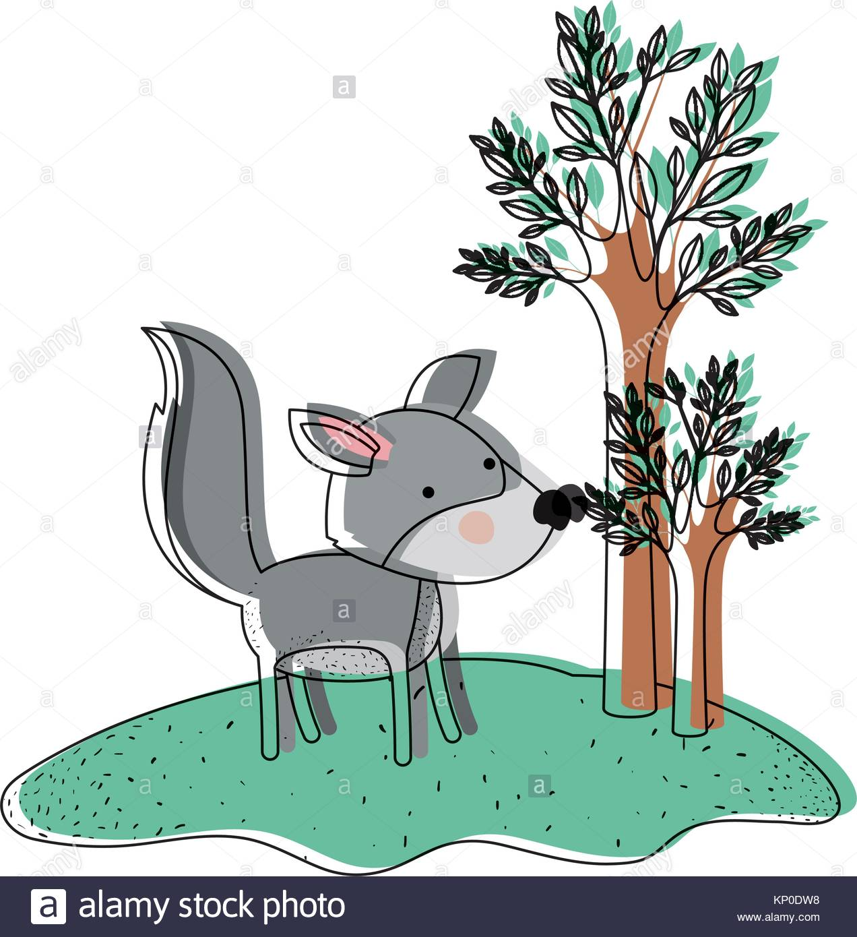

**Willow Class Termly Newsletter **

**Spring Term 3, 2021**